The bar chart comparison of mean PM2.5 concentrations across the three cities shows significant differences. Chicago has the highest PM2.5 levels (12.75 µg/m3 ), followed by NYC (6.90 µg/m3 ), with Boston having the lowest levels (1.84 µg/m3 ). The variability also differs substantially - Chicago shows both high mean values and high standard deviation (12.06), suggesting more extreme pollution events. NYC similarly shows high variability (std=13.99), while Boston’s air quality is both better and more consistent (std=0.77).

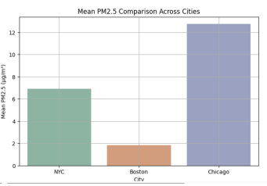

Statistical data for different cities:
 | city | mean | Std | min | max
0 | NYC | 6.896571 | 13.985542 | 0.000000 | 384.130000
2 | Boston | 1.837699 | 0.765489 | 0.464346 | 8.028841
4 | Chicago | 12.746455 | 12.057844 | 0.000000 | 2010.439941

